**Aaron Williams**

**Assignment 4**

**02 July 2017**

**Problem 1:**

Create a structure called car with the following members:

-make

-model

-year

-miles

Create an instance of the car structure named myCar, and assign data to each of the members. Print the contents of each member to standard output using the printf() function.

Output:

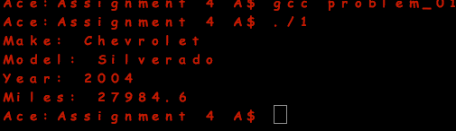

**Problem 2:**

Using the calloc() function, write a program that reads a user’s name from standard input. Use a loop to iterate through the memory allocated, counting the number of characters in the user’s name. The loop should stop when a memory segment is reached that was not used for reading and storing the users name. (Remember, calloc() initializes all memory allocated.) Print the number of characters in the user’s name to standard output.

Output:

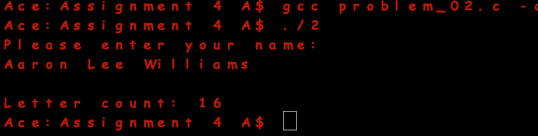

**Problem 3:**

a. Create a data file called superheroes.dat using any text-based editor, and enter at least three records storing superheroes’ names and main superpower. Make sure that each field in the record is separated by a space.

b. Using the superheroes.dat file from part a, build another program that uses the fscanf() function for reading each record and printing field information to standard output until the end-of-file is reached. Include an error-handling routine that notifies the user of any system errors and exits the program.

superheroes.dat:



Output:

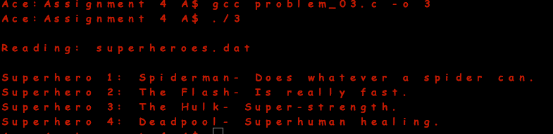

**Problem 4:**

What is the size of the string “Hello World”? What is the length of this array named s?

Char s[] = “Hello World”;

a. Write a c++ program that returns the length of s to support your answer.

b. Define a string instance called s1, copy the string “Hello World” in s1 the use the string length function to determine the length of s1 and display it.

Answer:

-The size of the string “Hello World” is 11.

-The length of the array s is 11.

Output:

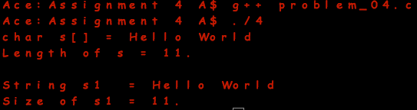

**Problem 5:**

List three reasons to use dynamic memory:

1) Dynamic memory allocation can be used when one is unsure of exactly how much memory to allocate, as it allows for allocation at run-time instead of compilation time.

2) Dynamic memory only utilizes the amount of memory required.

3) Dynamic memory allows for a large block of memory to be efficiently allocated and persist.